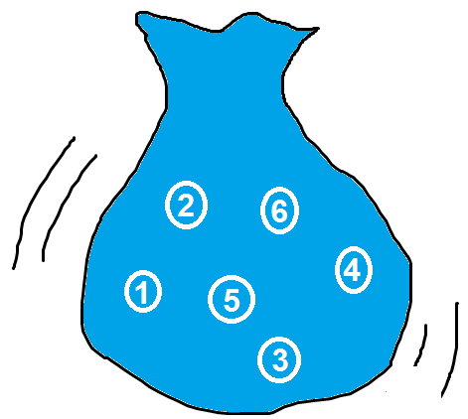
In the Mathsland National Lottery, six balls painted with the numbers 1 to 6 are placed in a bag.
To enter, you choose three numbers.
To win, your numbers must match (in any order) the three numbers that are drawn from the bag.
What is the probability of winning?

The Mathsland Lottery organisers decide to change to a simpler system where you just choose two numbers from the six, and then two numbers are drawn from the bag.
To win, both of your numbers must match.
How will this affect your chance of winning?
The two-number lottery is very unpopular, so the organisers move to a four-number (six ball) lottery instead.
How will this affect your chance of winning?
In their effort to find the most popular lottery, the organisers also trial a one-number and a five-number (six ball) lottery.
What can you say about the chances of winning these?
****************************************************************************************

The Mathsland Lottery organisers decide to move to a 10-ball lottery, but they can't decide how many numbers should be drawn.
The organisers want to make the chance of winning as low as possible! Can you advise them?

****************************************************************************************

When the UK National Lottery was first introduced it allowed you to choose six numbers from 49. What is the probability of winning the jackpot in the UK lottery?

